# [‘Law & Order’ brings 3 show casts together for 1st time in historic premiere event](https://www.today.com/popculture/tv/law-order-brings-3-casts-together-first-time-historic-crossover-rcna44435?cid=sm_npd_td_tw_ma)

The family's getting together, as "Law & Order," "SVU" and "Organized Crime" will share the screen in a crossover.

Aug. 24, 2022, 9:20 AM -03 / Source: TODAY

By [Randee Dawn](https://www.today.com/author/randee-dawn-tdpn196)

NBC has been airing some version of the "[Law & Order](https://www.today.com/popculture/tv/law-order-returns-season-21-premiere-compares-original-run-rcna17246)" franchise since 1990. That's hundreds of hours and episodes. So what *haven't* they done with the "L&O" shows, which currently encompass the return of the mothership, "[Law & Order: SVU](https://www.today.com/popculture/tv/mariska-hargitay-posts-new-pic-chris-meloni-law-order-set-rcna39869?search=)" and "[Organized Crime](https://www.today.com/popculture/tv/chris-meloni-posts-video-split-set-law-order-organized-crime-rcna27627?search=organized%20crime)"?

How about a three-way crossover?

"Law & Order: SVU" (l.-r.): Teresa Ting, Jeremy Russial, Mariska Hargitay and Christopher Meloni.Virginia Sherwood / NBCU Photo Bank via Getty Images

Your wish is Dick Wolf's (the creator of the long-running franchise) command. For the first time in the history of the show, three casts from its series will join forces in a special event on Thursday, Sept. 22, from 8-11 p.m. on NBC. It will air the following day on Peacock.

*(Peacock is part of our parent company, NBCUniversal.)*

The premiere event helps to kick off NBC's fall season and will wind a single story through the three series. In the story, a girl is shot, leading "L&O's" Detective Frank Cosgrove (Jeffrey Donovan) to pair up with Detective Jalen Shaw (Mehcad Brooks, in his debut episode).

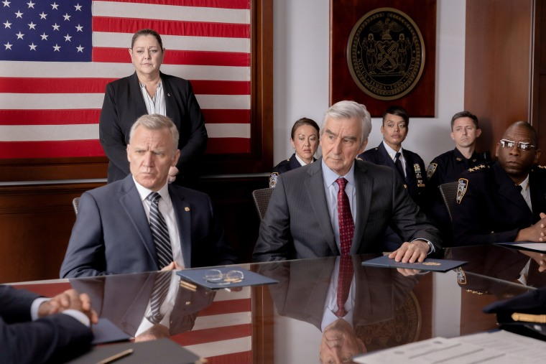"Law & Order" from l.-r.: Terry Serpico, Camryn Manheim and Sam Waterston.Eric Liebowitz / NBCU Photo Bank via Getty Images

"SVU's" [Capt. Olivia Benson (Mariska Hargitay)](https://www.today.com/popculture/500th-svu-episode-brings-flashbacks-returning-characters-t235156) and her former partner, now-turned "Organized Crime" star [Detective Elliot Stabler (Christopher Meloni)](https://www.today.com/popculture/tv/olivia-benson-elliot-stabler-relationship-timeline-law-and-order-svu-rcna37289) are brought in after the case widens. Key evidence draws [DA Jack McCoy (Sam Waterston)](https://www.today.com/video/sam-waterston-to-reprise-his-law-order-role-as-jack-mccoy-128976965849) and ADA Nolan Price (Hugh Dancy) (both from the mothership show) to an international crime ring but, unsurprisingly, complications arise.

### *Recommended*



### [TV](https://www.today.com/popculture/tv)[‘Grey’s Anatomy’ mini-reunion! See Sandra Oh’s pic from the Emmys](https://www.today.com/popculture/tv/greys-anatomy-mini-reunion-2022-emmy-awards-rcna47572)



### [TV](https://www.today.com/popculture/tv)[Is Caroline Manzo as Italian as the Olive Garden? Dolores Catania answers](https://www.today.com/popculture/tv/dolores-catania-caroline-manzo-celebrity-beef-rcna47508)

"Nothing demonstrates the power of the 'Law & Order' brand more than an ambitious three-hour event with a story that is truly ripped from the headlines that starts on 'Organized Crime,' then migrates to 'SVU' and finally the trial on 'Law & Order,'" Wolf said in a statement. "(Writers) Rick (Eid) and Gwen (Sigan) did an amazing job writing a compelling script and I can’t think of a bigger and better way to launch the new season of ‘Law & Order’ Thursday."

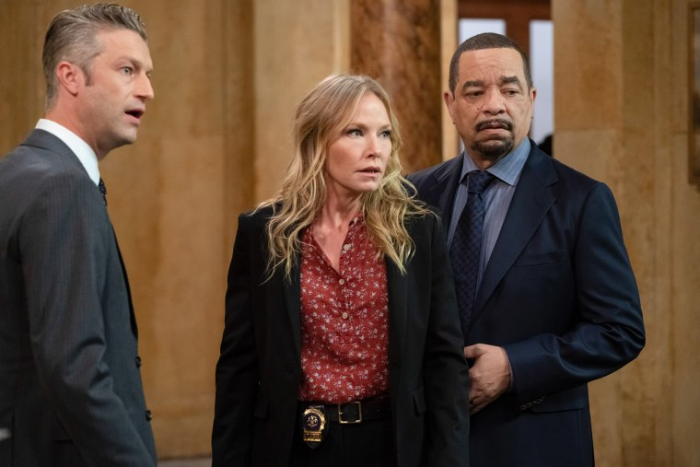"Law & Order: SVU's" Peter Scanavino (l.) with Kelli Giddish and Ice-T.Virginia Sherwood / NBCU Photo Bank / Getty Images

"L&O" has a history of [crossover episodes](https://www.today.com/popculture/benson-stabler-got-personal-law-order-christmas-crossover-t242774) from some of its earliest days. The original show shared cast and story with "Homicide: Life on the Street" multiple times, and characters have freely wandered between the series over the years. A three-part "L&O" aired in its seventh season (1996-97), with one case spread over three episodes. Wolf's other "[Chicago](https://www.today.com/popculture/tv/s-epatha-merkerson-chicago-med-crossover-idea-mariska-hargitay-svu-rcna29438?search=crossover+Law+%26+Order)" series has also crossed over with "L&O" shows.

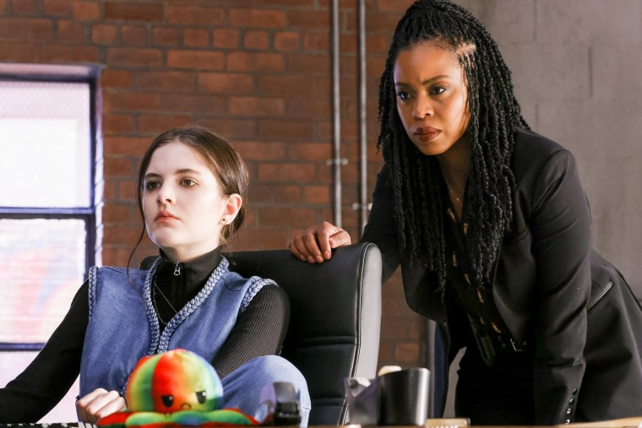"Law & Order: Organized Crime's" Ainsley Seiger (l.) and Danielle Moné Truitt.Will Hart / NBCU Photo Bank / Getty Images

Note to viewers: The shows will air in this order *—* “Organized Crime” at 8 p.m., “SVU” at 9 p.m. and “L&O” at 10 p.m. *—* without credits or title sequences between them. So if you set your DVR to watch them delayed, set it to record all *three* shows.

Or just watch them on Peacock the next day!